WICI2Mobile Label Creation Process

- Download and Install latest version of ZebraDesigner bar code label design software
  - Download ZebraDesigner tool by follow links:
http://www.zebra.com/us/en/products-services/software/zebralink/zebra-designer.html
or
http://www.zebra.com/id/zebra/na/en/index/products/software/label_design_software/zebradesignerpro/zebradesigner.htmlZebra.

  - Install ZebraDesigner bar code label design software.
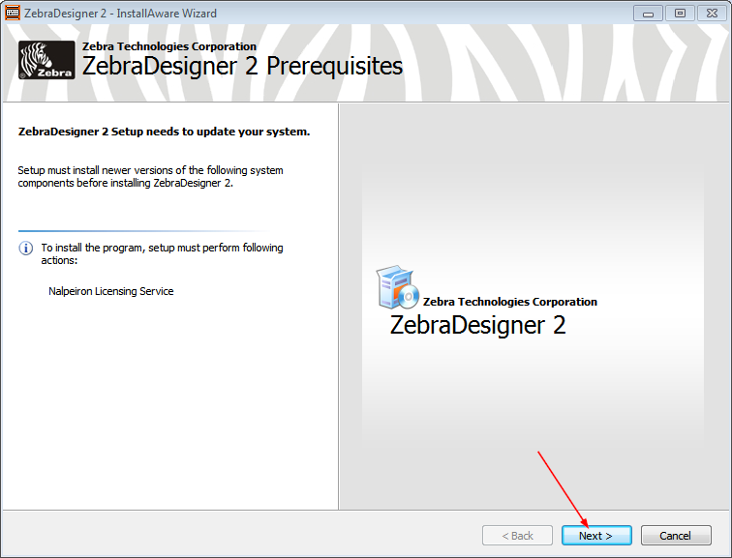

  - Run ZebraDesigner tool after installation.
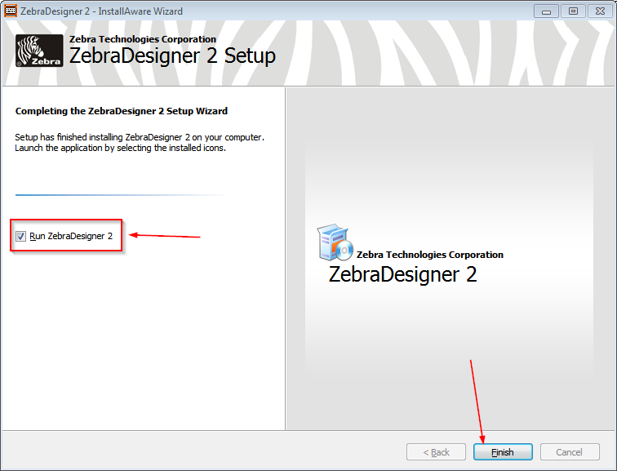

  - Add new Printer:
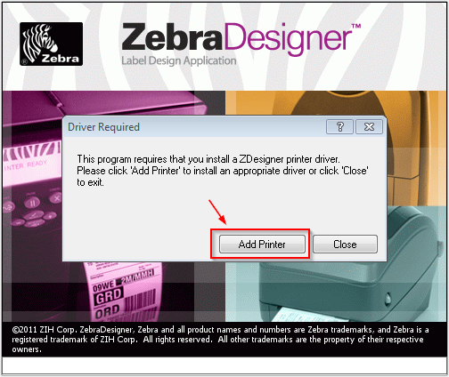

Press Next:
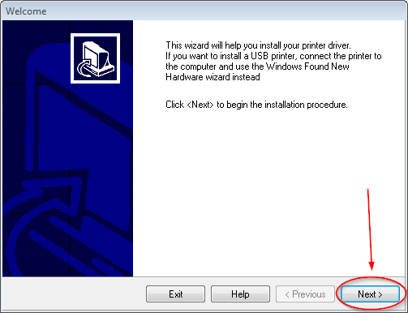
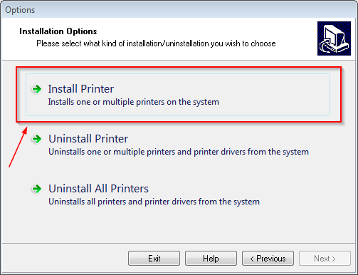

Select iMZ320 printer:
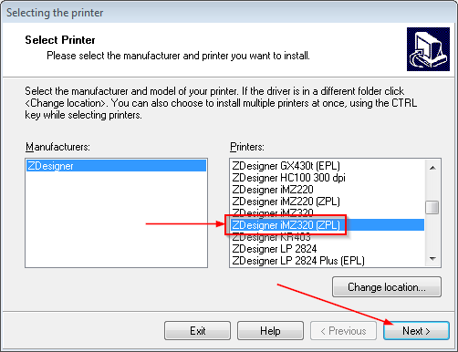

Select needed “available port” (should be USB)

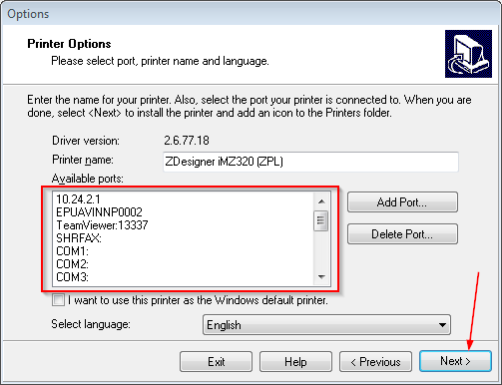

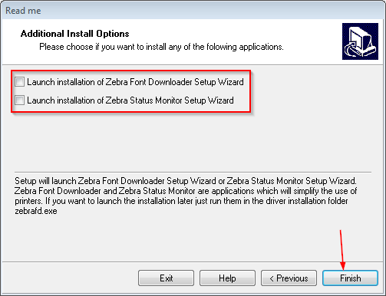

Install selected printer driver
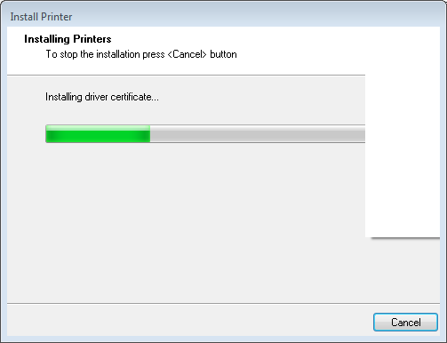

If follow warning message will be shown just click on “Next“ button:
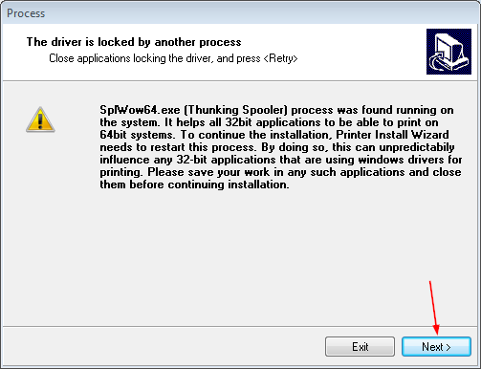

- Launch ZebraDesigner bar code label design software. Go to the desktop and double click on
ZebraDesigner shortcut icon:
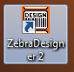
- Create new or open existing label
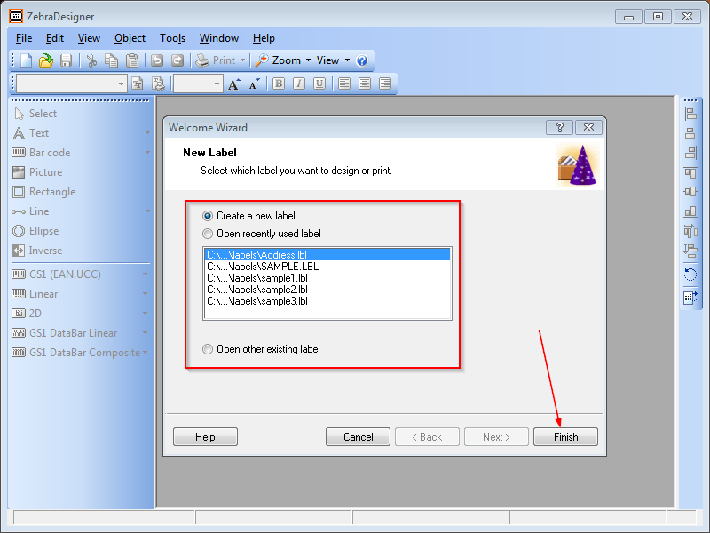

- Configure printer properties
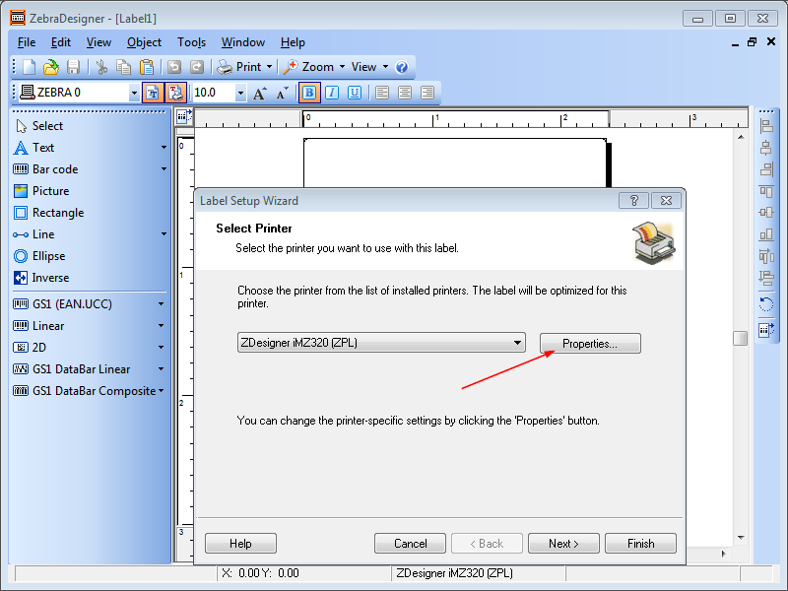
Set needed printer settings
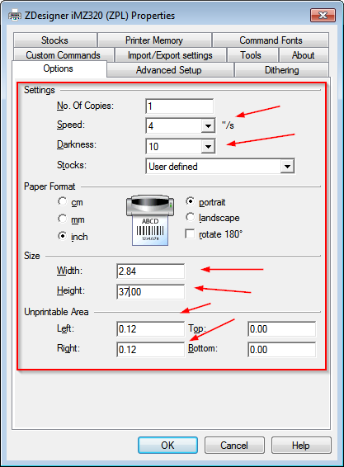

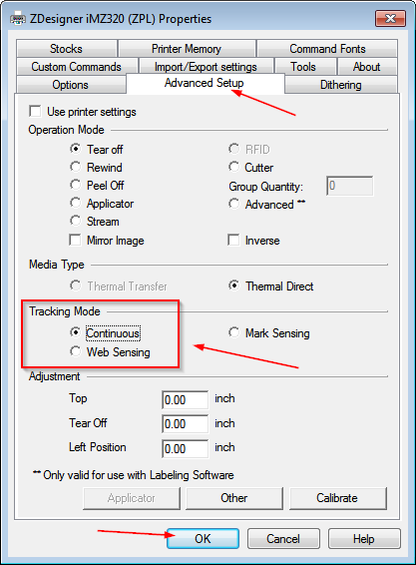

- Configure label settings
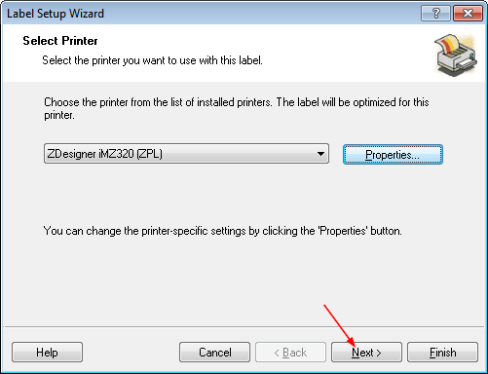

Set “Stock type” if needed
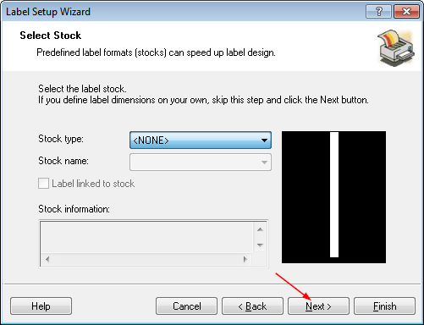

Change or set label size
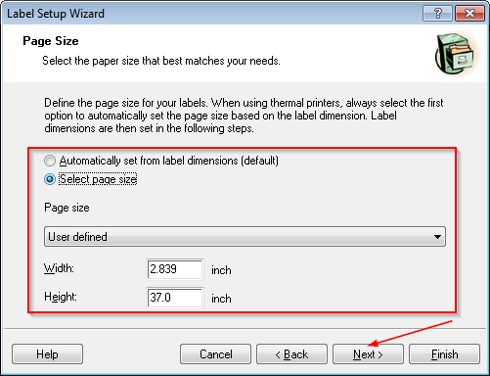

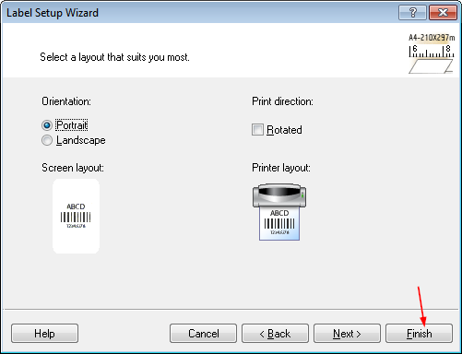

- Add or edit content for the created label
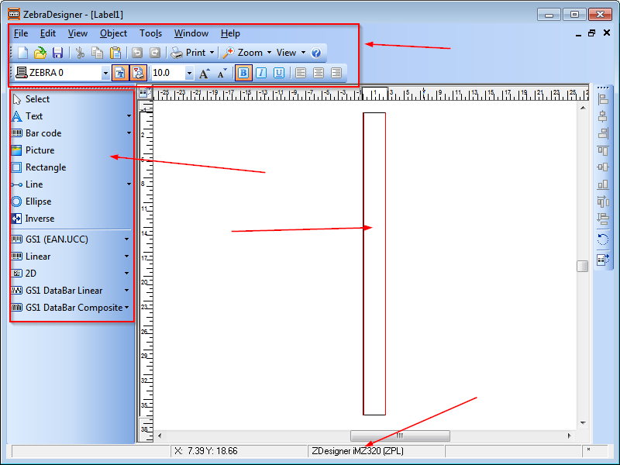

As example:
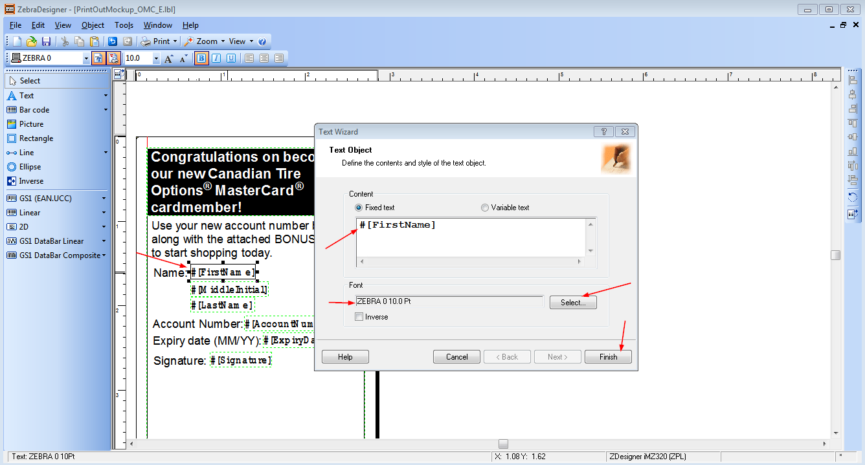
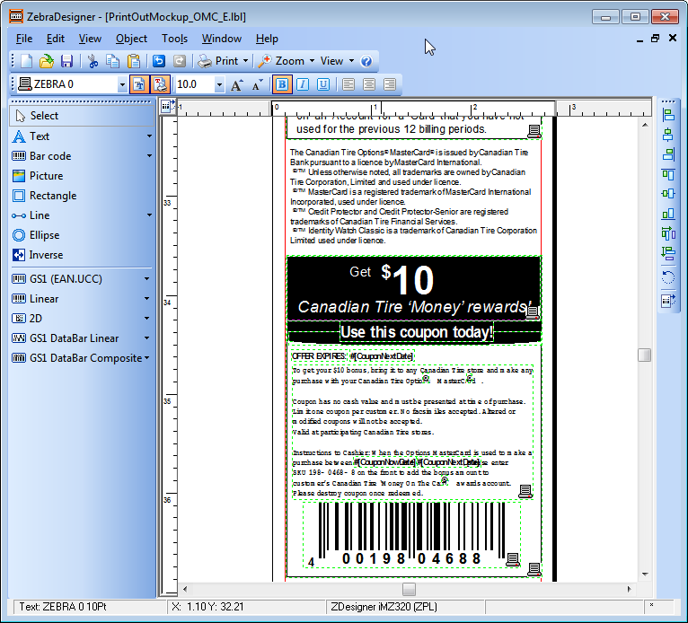

- Create “prn” file
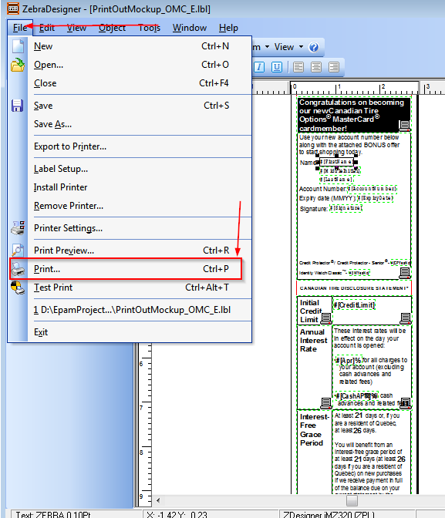

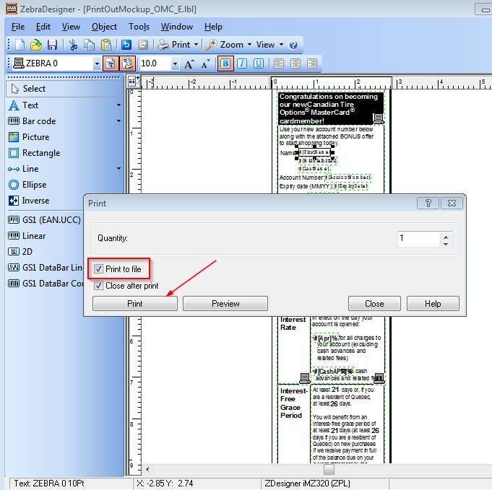

Define file location and name and click on “Save” button:
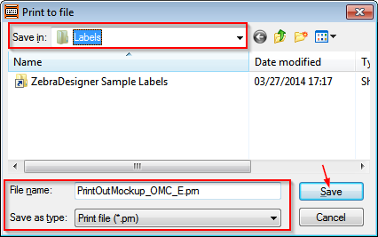

Example of the “prn” file content:
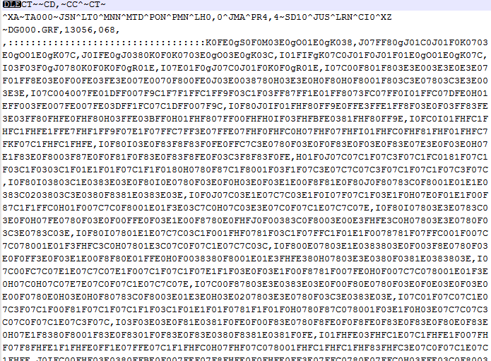

- Possible way to extend the max printing length:
Go to the: “C:\Program Files\Zebra Technologies\ZebraDesigner 2\Drivers\ZBRN\Win32 (and / or) \Win64” depending on your device.
Edit the “BAIMZ320Z.dat” file......
Change the "MaxHeight" variable to something higher.... I did 60000...
After you do this, re-install the ZPL printer in ZebraDesigner and double check your label setup to extend the length beyond 40".

- We also update generated “prn”files from our java code on WICIMobile application side. This is short information about all classes related to this process:
WICIReplacementHelper contains list of strategies that are used for string replacement in template:
WICICardReplacementStrategy
WICICardTermsReplacementStrategy
WICIAccountShopingReplacementStrategy
WICIAccountNumberReplacementStrategy
WICIExpiryDateReplacementStrategy
WICICreditLimitReplacementStrategy
WICISimpleTextReplacementStrategy
WICISignatureReplacementStrategy

ApplyReplacement - in this helper walks through all replacement strategies and apply replacements. Values for replacement are taken from WICICardmemberModel.

